Ornaments as indicators of Social change before and after European contact at Kiwulan, Northeastern Taiwan

Li-Ying Wang

Ben Marwick

08 August, 2019

Text of abstract

# Introduction

The direct impacts of European colonialism on indigenous communities in East Asia were much less pronounced than island Southeast Asia and Oceania. Throughout East Asia direct colonial rule was rare and limited, but the question of long-lasting indirect impacts on local indigenous communities remains largely unanswered. Understanding the indirect effects of colonialism are important for detecting colonial impacts on indigenous peoples in the periphery of colonial control (Torrence and Clarke, 2000; Trabert, 2017). In many parts of the world, the introduction of foreign trade goods by colonial traders into local indigenous societies caused significant transformations of indigenous economic, cultural, and socio-political systems (Dietler, 1997; Junker, 1993; Mitchell, 2000; Silliman, 2005). The agency of indigenous peoples in the colonial contexts has been broadly discussed to understand the negotiations between colonized and colonizer, and the resistance and accommodations of indigenous people through their daily cultural practices (Dietler, 2015; Given, 2004; Rubertone, 2000; Silliman, 2001; Torrence, 2000; Torrence and Clarke, 2000; Voss, 2005). Studying the consumption of foreign goods is one way to understand indigenous experiences of colonial encounters and explore the agency of indigenous peoples by examining how goods were distributed and used (Dietler, 2005; Mullins, 2011; Scaramelli and Scaramelli, 2005).

Taiwan became part of global trade systems during the early 17th century due to western European expansions that connected Europe and Asia. Despite colonization of Taiwan by the Spanish and Dutch from 1624 to 1662, there has been little discussion of the archaeology of indigenous responses to the European colonization. Berrocal et al. (2018) study both archaeological and historical records of Heping Dao in northern Taiwan that was the location of the colony of San Salvador founded by the Spanish in 1626 and took over by the Dutch in 1642. They uncovered parts of the foundation of a Spanish church and a European cemetery that indicate the evidence of European occupation. It shows a direct impact on the local indigenous populations by disturbing their long settlement pattern and changing local landscape. Different from the view of a Spanish fort, Yilan in Northeastern Taiwan is an especially unique location for exploring indirect colonial effects on local indigenous settlements due to its physically isolated location. The rugged Hsuehshan Range to the west and Central Range to the south of the Yilan Plain that made it not easily accessible to the European colonists and the colonial control was weaker compared to other parts of this region (Andrade, 2007; Kang, 2012). The sea provides a way through which indigenous people in Yilan could interact with other groups from different regions, including other native indigenous groups, foreign traders such as the Han people of China, and Europeans. Large-scale and frequent trade activities brought a wide variety of trade objects into indigenous communities in Yilan through local regional exchange network. One of the most common types of trade goods in this region were personal ornaments such as glass and stone beads was one of the common foreign goods found at the settlement sites in this region (Chen, 2007; Li and Chiu, 2014; National Musuem of Taiwan History, 2005). Personal adornments are a social signal of an individual’s status (Joyce, 2005; Scaramelli and Scaramelli, 2005). For example, the consumption of stone beads in Southeast Asia during Iron Age is often associated with increasing social stratification or socio-political complexity (Bellina, 2014; Carter, 2016; Francis, 2002; Kenoyer, 2000; Theunissen et al., 2000).

In this paper, I explore the evidence from Yilan spanning from late Iron Age to historical period to address the question of whether indirect colonial influences on indigenous populations can be detected. I focus on the ornaments recovered from the archaeological excavations at Kiwulan (1400-1900 AD), a large Iron Age settlement in northeastern Taiwan (Chen, 2007). Prior to the contact with the Europeans in the early 17th century, Taiwan had been involved in both regional and long-distance East and Southeast Asian trade systems since tenth century, and encountered large waves of Han Chinese immigration after 17th century since Taiwan was incorporate into the territories of Qing Dynasty of China (Andrade, 2007, ch. 11; Liu and Wang, 2017). Northeastern Taiwan provides a good example to explore the indirect colonial impacts on indigenous societies by comparing archaeological evidence from different episodes of culture contact [cf.@Lape2003]. I will describe the variety and cultural context of trade ornaments in this region, and examine their potential of the ornaments to inform on social changes relating to trade with colonial groups. I hypothesize that there was a greater diversity of ornaments types and materials at Kiwulan after European contact due to participation in a larger scale exchange network. I also predict that after European contact there will be new spatial patterns in the distributions of ornaments at Kiwulan that indicates increasing social inequality. I hypothesize that after Chinese contact there was a decline in the use and discard of ornaments at Kiwulan due to overall population declines and acculturation in Chinese community.

# Cultural context of ornaments in Yilan, northeastern Taiwan

Northeastern Taiwan was part of the local exchange network in northern Taiwan, where the indigenous people had already established their own exchange network before European arrived that has been described as “inter-insular trade” by Chen Chen (2005, p. 12) to refer to small-scale regional trade between China and Taiwan on irregular basis. The exchange network in northern Taiwan was increasingly influenced by long distance trade between Fuzhou or Quanzhou in China and Ryukyu in Japan since 15th century due to its location on the shipping routes (Chen, 2005). This was intensified in the 17th century with the arrival of the Europeans and their trade goods (Wang and Liu, 2007). Due to its location on the periphery of major trade ports, Keelung and Tamsui, in northern Taiwan, Yilan was involved in this network through the periodic exchange activities between different indigenous groups. Yilan, also called “Kavalan” by local indigenous people, is an alluvial plain circumscribed by the Pacific and mountains on the sides. Rivers and seas provide the way for the interaction between local indigenous settlements and further afield communities, such as the Basai in northern Taiwan and Han Chinese. Kavalan people offered rice, deer hides, and gold in exchange for beads, metal tools or ornaments, ironwares, porcelains, and textiles with outside traders (Chen, 2005; Hsieh, 2009; Li and Wu, 2006).

Historical documents from the Spanish and Dutch in the early 17th century provide some information about the social life and culture of indigenous people in Northern Taiwan when the Europeans arrived. The Spanish founded Fort San Salvador at Keelung in 1626 and Fort San Domingo in 1629 at Tamsui, and sent missionaries to local indigenous settlements in this region for religious purpose (Blussé and Everts, 2000, p. 343). The report of the Dominican priest Fr. Jacinto Esquivel in 1632 mentioned that the Taparri, an indigenous tribe from northern Taiwan, usually used cuentas (agate beads) in exchange for necessities with other indigenous groups. This form of exchange was widespread and even the Spanish soldiers learned to use agate as bargaining chips for gambling (Li and Wu, 2006, pp. 132–149). Esquivel also recorded how indigenous people viewed agate pieces as prestige goods in their culture. A indigenous man who wanted to get married had to pay agate beads to the parents of his future wife. Also, agate or golden beads could be used as to resolve conflicts in their daily lives (Li and Wu, 2006, p. 151). Other records mention that the female shamans (majuorbol) in the tribe would use agate beads as magical items in ritual practice for body healing(Borao, 2009, pp. 122–151). An indigenous funeral process was recorded, documenting the use of agate beads in ritual contexts, with more agate beads, pottery and cloths placed into the graves of more influential people to indicate a family’s higher prestige (Li and Wu, 2006, p. 153). Those historical accounts indicate that agate beads or golden beads were already treated as prestige goods before the arrival of the Europeans. These were likely introduced earlier from Chinese traders.

In 1642, the Dutch VOC defeated the Spanish and took over their forts in northern Taiwan. They introduced a feudal system in an attempt to control the indigenous communities by asking indigenous leaders to attend annual ceremony for demonstrate their loyalty (Andrade, 2007, ch. 9; Kang, 2016, ch. 4). The Dutch provided beads and other goods based on the demands of Indigenous people to secure alliances in the annual ceremony or during traveling (Kang, 2016, ch. 6). Thus, I assume that the Dutch feudal system resulted in an increase in the amount and diversity of ornaments in northeastern indigenous communities during this period.

Chinese historical records from the year of 1829, 1837, and 1852 during the Qing dynasty [1616-1911] contain some notes on the purposes of ornaments from Yilan (Chen, 1963, pp. 228, 308; Ke, 1993, pp. 11, 126; Yao, 1996, p. 77). According to those records, indigenous people in Yilan had a custom to wear ornaments in ceremonial contexts to display their wealth and status. Among those ornaments, golden fish-shaped necklaces made of copper threads had higher value due to its delicacy and more materials invested in production. These were usually possessed by wealthy people. Other people wore agate beads or glass beads on their head or neck to participate in ceremonies. In 1895, at the beginning of Japanese colonization, a field survey for plains indigenous groups reported that golden necklaces were not used in Yilan at that time, but elderly people still used beads (Ino, 1996, pp. 227–232)

Recent ethnographic research with the living members of the Kavalan tribe describes how agate beads were used in divination practices, called “subli”, by female shamans (Liu, 2008, pp. 133–134). Interview records mention agate beads as valuable objects that are usually passed down from mother to daughter as a heirlooms in shaman families, without knowing the exact origin. When not in use, beads were often hidden in safe places, such as on the roof beams. Modern ethnographic research shows that agate beads were not only used as decoration, but also played an important role in divination, consistent with observations from the European colonial period. It was usually the female shamans conducting divination rituals that passed the beads down from their ancestors. Despite most Kavalan people today not knowing the specific origin of their agate beads, the value of beads is still highlighted through oral history and by their scarcity. In sum, we find multiple sources describing how local Indigenous people used ornaments in cultural contexts that represents some social roles or high status. However, compared to European contact period, there are fewer mentions of beads in Chinese contact period and the descriptions are limited to clothing, but generally confirm the role of beads as status markers.

# Excavations at Kiwulan in northeastern Taiwan

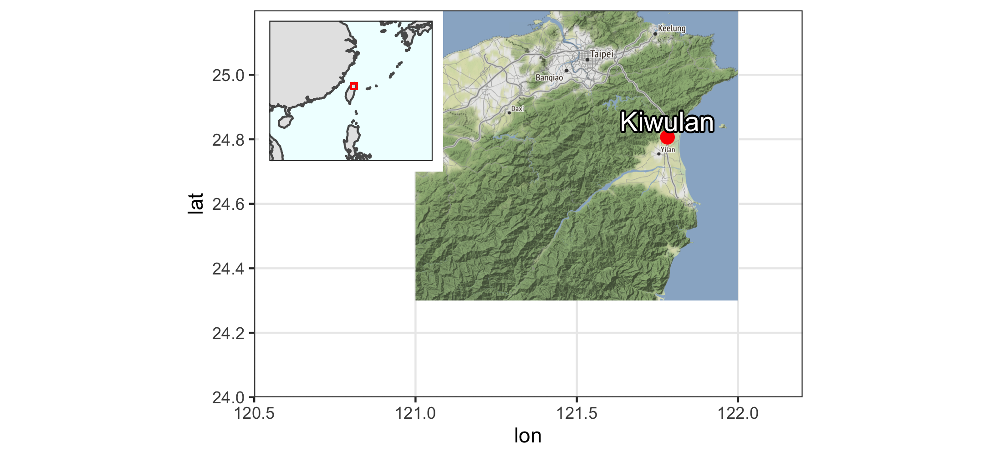

Figure 1: Map showing the location of Kiwulan, and other places in northern Taiwan named in the text

Figure 2: Map showing the largest section of excavation areas at Kiwulan, and the distribution of forty squares sampled in this paper presented in red with square ID number. Each square is 4 x 4 m

Figure 2: Map showing the largest section of excavation areas at Kiwulan, and the distribution of forty squares sampled in this paper presented in red with square ID number. Each square is 4 x 4 m

Kiwulan 1 is located at northern Yilan and was a rescue archaeology projects that carried out from 2001 to 2004 in advance of water diversion project and construction of a road bridge. The total area includes eight open area sections of 262 squares (4 m by 4 m) reaching 3,814 m2 in total (Chen, 2007). The archaeological evidence includes a large amount of artifacts, burials, middens, post holes, wooden pillars, and stone structures, all of which indicates it was a settlement. Most ornaments were found in situ while digging and some were collected through screens with 2 mm and 1.5 mm mesh. The ornaments studied in this paper were found from 40 adjacent squares in the largest open area, located in the middle part of excavation (2). They were sampled because those units were stratigraphically intact with the least disturbance by modern construction activity, compared to excavation squares on the periphery of the site.

The chronology of Kiwulan can be divided into two phases represented by a Lower Layer Culture (700 - 1200 AD) and a Upper Layer Culture (1400 - 1900 AD) with a sterile layer in between. This chronology is based on the stratigraphy and a series of 32 radiocarbon dates (Chen, 2007). This paper focuses on the Upper Layer Culture spanning from the late Iron Age to the historical period starting from the 17th century with European contact in Taiwan.

Previous researchers divided the Upper Layer Culture component into six layers spanning from the 14th century to the 19th century with a hundred year intervals according to original radiocarbon dates, excavation depth, and types of diagnostic porcelains such as blue and white porcelains (Hsieh, 2009; Wang, 2011). The layers were assigned numbers from 1 to 6 where L1 corresponds to the youngest layer and L6, the bottom layer, refers to the oldest layer. However, because the specific methods of assigning layers to a time period was not documented in detail for the previous chronology, I reexamined the excavation records to produce a new chronology for the sampled squares. For each sampled square I separated excavation units into three episodes of time: pre-European contact period (L5 and L6), European contact period (L4), and Chinese contact period (L2 and L1).

I identify the start of European contact at Kiwulan at 1632, when the local villages were attacked by the Spanish who took revenge on an incident happened earlier that year (Borao, 2001, p. 163). Later in 1647, the Dutch attacked the indigenous villages and forced them to accept colonial rules and economic demands by paying annual tribute (Andrade, 2007). According to Dutch census reports in 1650, Kiwulan was the largest indigenous settlement in the plain, with a population of 840 adults (Nakamura, 1938, p. 12). I take approximate indicators of the start of European contact at Kiwulan as the appearance of An-ping jars and stonewares (martavans/martaban) that were largely introduced to Taiwan during the early 17th century. They are frequently found in European shipwrecks from this period for transporting water, wine or other fluids on the long voyages, and the jar shapes found at Kiwulan are typical of those found elsewhere in V.O.C sites occupied during the 17th century (**???**; Berrocal et al., 2018, p. 917; Cort, 2017, p. 282; Grave and McNiven, 2013; Ketel, 2011). I used the presence and absence of An-ping jars and stonewares, together with the radiocarbon dates, to identify excavation units associated with the pre-European and post-European periods. European colonization ended in 1662 when they were defeated by the kingdom of Tungning founded by Koxinga from China. Later in 1683, the Qing dynasty ruled over Taiwan and a large wave of Han Chinese migrated to Yilan during the late 18th century. I recognize this as the Chinese contact period, which is archaeologically visible at Kiwulan by large amount and varieties of Chinese porcelains, clay stoves, and a few opium pipe-bowls that were identified as items commonly used in daily life of Chinese and the use of bricks and tiles for architectural buildings (Hsieh, 2009). Also, the description of the Chinese migration can be seen from the Chinese official records written in the early 19th century (Chen, 1963; Ke, 1993).

# The ornaments

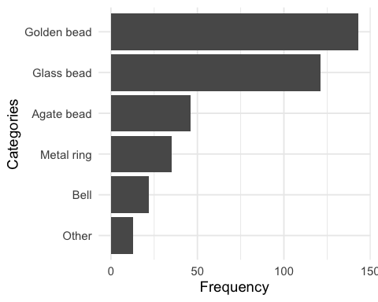

Figure 3: Frequency of the major class of ornaments at Kiwulan from sampling area

Table 1: A table of ornament subtypes

|  |  |  |  |  |
| --- | --- | --- | --- | --- |
| Categories | Type | Before European Contact | European Contact | Chinese Contact |
| Agate bead | hexagonal | 6 | 17 | 5 |
| Agate bead | waxy oval | 0 | 4 | 0 |
| Agate bead | small oval | 3 | 3 | 0 |
| Agate bead | globular | 0 | 1 | 0 |
| Agate bead | pentagonal | 0 | 1 | 0 |
| Agate bead | big oval | 0 | 0 | 1 |
| Agate bead | long bicone | 0 | 0 | 1 |
| Agate bead | octagonal | 0 | 0 | 1 |
| Bell | large | 3 | 8 | 3 |
| Bell | plain small | 0 | 4 | 1 |
| Bell | thin small | 0 | 1 | 1 |
| Glass bead | small bead | 60 | 37 | 1 |
| Glass bead | medium bead | 8 | 15 | 0 |
| Golden bead | NA | 48 | 93 | 2 |
| Metal ring | wide small | 1 | 9 | 1 |
| Metal ring | thin large | 4 | 5 | 2 |
| Metal ring | wide large | 0 | 5 | 0 |
| Metal ring | overlapped | 0 | 2 | 0 |
| Metal ring | braid | 0 | 1 | 0 |
| Metal ring | entwined | 1 | 1 | 0 |
| Metal ring | flat | 0 | 1 | 0 |
| Metal ring | large thick string | 0 | 1 | 0 |
| Metal ring | small thin string | 0 | 1 | 0 |

#> contexts sampling total_KWL percent_context sam_total_percent  
#> 1 post hole area 406 873 11.3 46.5  
#> 2 burials 3173 6769 88.0 46.9  
#> 3 middens 27 55 0.7 49.1  
#> 4 sum 3606 7697 NA NA



Figure 4: Subtypes of ornament in each major category. A: agate beads, B: bells, C: glass beads and golden beads, D: metal rings. Photographs are presented in the same order as those subtypes in the table but from left to right instead. The photographs of B, C, D categories were from original excavation report (Chen 2007).

Ornaments from 40 sampling squares were excavated in-situ in different archaeological contexts, including 406 pieces from post-hole area, 3173 pieces from burials, and 27 pieces from middens. Burials unearthed large amount of ornaments because most beads were preserved well in the form of bead strings that consist of hundreds to thousand pieces. In this paper I focus on the post hole area where 406 ornaments were recovered, which accounts for 46.5 % of the total number from the same context in the Upper Layer Culture at Kiwulan. Post hole area represents Kiwulan domestic space that provides a clear contexts and basis for comparison to see if there is any spatial pattern of distribution. Figure 3 shows that the most common ornament is golden bead with the number of 143, followed by 121 glass beads, 46 agate beads, 35 metal rings, and 22 metal bells. The variety of subtype and their individual frequency are summarized in Table 1 in terms of three time episodes. The image for each subtype in each major category is shown in Figure 4.

Ornaments were found in 30 burials from the sampling area as grave goods. Their positions in burials in association with particular parts of human remains indicate the purpose of body adornment. For example, agate beads, golden beads, and small metal rings were often found near skulls that indicate the use as necklaces or ear rings, while big metal rings were found wearing on radius and ulna bones as bangles. This pattern corresponds to the texts regarding the body decorations of indigenous culture from Chinese historical documents (Chen, 1963; Ke, 1993). Agate beads were mostly found in female burials with the average of 4 to 5 pieces, while golden beads were found in both gender with the average of 2 to 3 pieces.

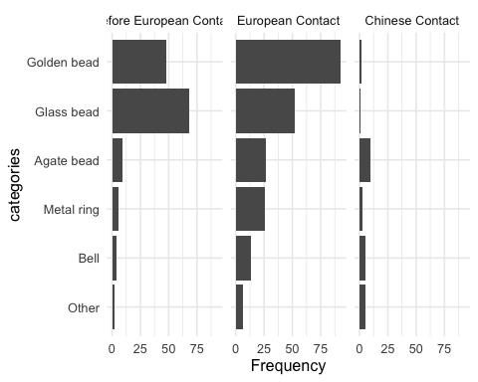

Figure 5: Frequency of the major ornament across different time periods.

# Results of hypothesis testing

In this section I report the tests of the three hypotheses about indirect impacts of European colonization on the indigenous community at Kiwulan. To test the hypothesis of a greater diversity of ornaments types and materials at Kiwulan after European contact, and a lesser diversity after Chinese contact, I compare frequencies of ornament types between different time periods. To test the prediction that after European contact were new spatial patterns in the distributions of ornaments at Kiwulan, I use kernel density and point pattern analyses.

## Frequency of ornaments between time periods

Figure 5 shows the comparison of ornament type frequencies between different time periods at Kiwulan. It indicates a general pattern that most ornament types were present before European contact. The frequencies reached a peak during the European contact and then dropped during the Chinese contact period, especially for golden beads. This trend can be also seen on other ornaments including agate bead, metal ring, and bell. However, glass beads show a different pattern that indicates a higher frequency in the pre-European contact, and then their frequency decreased in the European contact period and was even much less in the Chinese contact period.

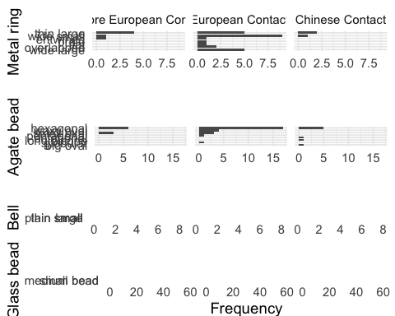

Figure 6: Frequency of ornament subtypes showing the changes in frequency across contact periods for metal rings, agate beads, bells, and glass beads.

The distribution of frequency for subtypes in each major category are presented in Figure 6. The distribution shows that agate beads and metal rings have greater quantity and of shapes compared to copper bell and glass beads during the European contact period. Agate beads can be divided into seven subtypes, in which hexagonal shape is the most common subtype that appeared before European contact and increased significantly during the European contact and then declined in the Chinese contact. The small oval type shows a similar frequency before and during European contact but is not found in the Chinese contact period. Waxy oval beads were only found during European contact period. A higher variety of agate beads were found in European contact compared to other time periods. Similarly, metal rings can be classified into eight subtypes, in which wide small ring is the most common metal ornaments, followed by wide large and thin large shape. The greater varieties for those two categories might indicate multiple origins due to global trade networks stimulated by the Europeans. In contrast, copper bell and glass bead have less variety, but glass beads have a larger number because they were usually found in a cluster that indicates the original use as strings or necklaces. The common shape for copper bells is the large shape with a wide variety of human faces as a motif, while the common shape for glass beads is a bead with length less than 1 cm that are often identified as Indo-Pacific beads, the most common type that had been widespread in Southeast Asian sites since 300 BC (Francis, 2002).

<—I think we need an addition bit of analysis in this section to show the relationship between diversity and sample size. We naturally expect diversity to increase as sample size increases. So we want to test and see if the changes in diversity that you describe here are only the natural effects of increase/decrease in sample size, or there are ‘real’ increases in diversity that cannot be explained by sample size changes. The peer reviewers will want to know the answers to this. —>

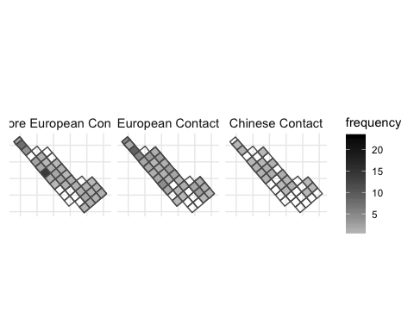

Figure 7: Spatial pattern of all class of ornament by time periods

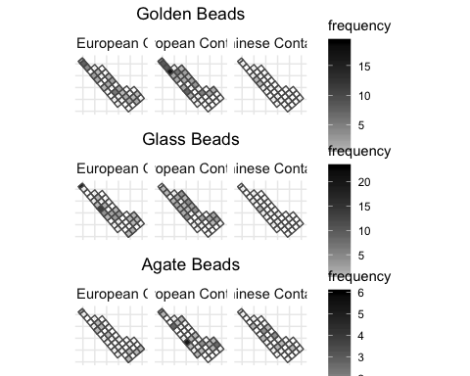

Figure 8: Spatial pattern for ornament class by time periods, only those types with more than 5 pieces are shown here

## Spatial distribution of ornament types

Figure 8 presents the spatial distribution of the main ornament classes for each time period. Before the European contact, the map shows a greater amount of glass beads found at the northern and middle parts of the research area, and they were more widespread during the European contact period. During the European contact period, ornaments were more ubiquitous with some clusters on northern part, and less abundance during the Chinese contact period. When looking at the distribution for each major class individually, some clusters across the area can be observed during European contact, including golden beads, agate beads, metal rings, and bells. However, there seems to be no clear consistent clustered pattern across those different ornaments. Each class shows its own pattern where the squares with higher number of ornaments distributed separately and independently. For example, the cluster of golden beads was found at the northern part, while the cluster of agate beads was found in the middle part. In contrast, there are multiple clusters of metal rings that are distributed separately across the research area. Copper bells were usually found individually and seem randomly distributed across the area. In the Chinese Contact period, both the amount and density of different classes of ornaments decreased that they were only found in a few squares, for example, golden beads and glass beads were only found in a few squares in the middle part.

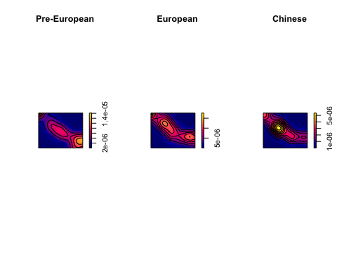

Figure 9: Kernal density map for ornaments by periods

## Point pattern analysis of ornament distribution

I used point pattern analysis to examine whether the distribution of ornaments was uneven in non-random ways that could reflect the presence of social inequality. Point pattern analysis is a way to assess whether the distribution of sites or artifacts represent some “hotspots” produced by non-random processes, implying the influence of social processes (Bevan and Lake, 2016; Ducke, 2015). In this case hotspots in the pattern of ornaments could indicate the changes in social organization due to culture contact. I used the intensity approach that focuses on the average density of points across space to explore their distribution. Ornament location points were given random coordinates within each square they were recovered from because their exact recovery location in each square was not recorded during excavation. The next step was to subset the ornaments into three groups for three time periods, and then compute the kernel density for each time period for comparison.

Kernel density estimations (KDE) estimate the probability of the density of events across space by creating a continuous, smooth density surface across space. Here we use KDE to visualize the event of the presence of ornaments that were represented by maps on which we are able to see core areas and surrounding neighborhoods (Bonnier et al., 2019; Cortegoso et al., 2016). Density values of artifacts per square meter are assigned to each cell. The results in Figure 9 show that there is one major core area during the pre-European contact period, multiple core areas during European contact period, and a single core during the Chinese contact period. Those maps present three consistent sub-regions with a core area that shifts over time. The distribution might indicate different social groups who possessed more ornaments. The multiple groups during European contact period might reflect more unequal consumption of ornaments across the site, relative to other periods. However, the generation of core areas might be biased due to small sample size, for example, a few ornaments found at one single square during the Chinese period could create an obvious hot spot. To further evaluate the pattern, we test the hypothesis that the distribution of ornaments is randomly distributed to understand the underlying social processes related to ornament distributions.

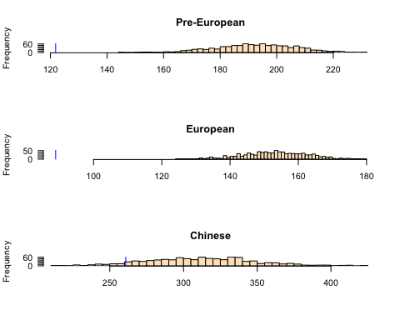

Figure 10: Histogram of simulated ANN values with the blue line indicating the observed value

Here we use a Monte Carlo method to test the spatial randomness of spatial events based on the average nearest-neighbor distance method (ANN). Our null hypothesis is that the distribution of ornaments is consistent with a completely random process, so we then simulate the locations of ornaments across the space 1000 times for each time period. The observed data was compared to the random pattern generated by simulated processes to see if our data is randomly distributed or not. Figure 10 shows the distributions of the ANN distances calculated on 1000 simulations of ornament locations. The results show that 100% of the simulated values are much more greater than our observed ANN value during the European contact period, which means the ornaments have a non-random clustered distributions. A similar, but less extreme, result is also observed during the pre-European period. The observed distribution of ornaments is more similar to the random distributions during the Chinese contact period, with about one third of the simulated values are greater than our observed ANN value. This testing reveals that the clustered distributions of ornaments during the pre-European and European contact periods might reflect the presence of different social groups. Moreover, the clustering of ornaments during the European contact period is highly non-random, potentially indicate some social changes leasing to a concentration of power to control the distribution of ornaments at Kiwulan.

# Discussion

The results show there was a greater diversity of ornaments types and materials at Kiwulan during European contact. This might result from the large scale exchange network that stimulated the circulation of different ornament classes. Among those ornaments, agate beads and metal rings have greater quantity and variety of shapes compared to copper bells and glass beads, which might indicate their diverse origins. However, the frequency of overall ornaments and each subtype declines significantly during the Chinese contact period. The reason could be related to a smaller scale of network, the overall decline of the indigenous population in Yilan, and adopting the mortuary practices of Han Chinese. Since the end of the 18th century, lots of indigenous people moved southwards to Hualien due to population pressure caused by the great amount of Han Chinese immigrants (Chen, 2007). According to the Chinese census reports in 1821 and Japanese field survey in 1895, the Kiwulan population was less than 100 that dropped by nearly 90 percent compared with the last census in the 17th century (Ino, 1898; Yao, 1996). In addition, burials after 18th century unearthed fewer ornaments or even lack of them that might indicate a change in mortuary practices. This can be also identified by the presence of coffin-like case that was viewed as a funerary item of Han Chinese, however, with local indigenous carving patterns on the wooden surfaces (Chen, 2007; Chiu, 2004).

The spatial pattern of ornaments shows that their distribution was clustered since the pre-European and European contact period. Hypothesis testing for spatial patterns further indicates that these clusters are non-random, and are concentrated during European contact. Because trade ornaments were prestige goods in prehistoric Northeastern Taiwan, this spatial clustering could indicate that a degree of social inequality was present before European contact and then it was reinforced and amplified during the European contact period. In addition, there was a burial dated to 17th century unearthed 60 golden beads above the average of 2-3 pieces that hints the possibility of increasing social inequality (Chen, 2007; Cheng, 2008). In Taiwan, most prehistoric organization were thought as egalitarian societies because of the lack of centralization of power that is often used as a major indicator of hierarchical complexity. However, this concept of egalitarianism has been challenged by evidence of social inequalities such as uneven distributions of prestige goods or the emergence of influential individuals in some non- hierarchical human societies (Ames, 2010; Bowles et al., 2010; Woodburn, 1982).

Horizontal complexity is another approach to discuss the emergence of social inequity by focusing on how people achieve and maintain power in a wide variety of societies (Drennan et al., 2010; Feinman, 2000). For example, the corporate/network model proposed by Feinman (2000) that expands traditional hierarchical complexity to provide a comparative basis for distinct strategies for power. In the network mode, inequality develops when individuals accumulate wealth through individual networks and use wealth to attract factions, control resources, and monopolize trade networks. In contrast, the corporate mode stresses shared power across different groups and sectors, integrative ceremonies and rituals, and large cooperative labor tasks (Feinman, 2000; Siegel, 1999). Applying the corporate/network model may give insight into the underlying pathways that led to social inequality in northeastern Taiwan. In the circumscribed environments of the Yilan Plain, the corporate/network continuum will provide a comparative basis to explore the impact of European contact on changes in the degree of indigenous social inequality. One insight emerging from this model is that the long-distance trade network introduced by the Europeans results in the appearance of a network mode due to the competitions among ambitious individuals for prestige, wealth, or power through collecting trade goods (Brumfiel, 1994; Clark and Blake, 1994). Because of the weak direct control from the European colonizers in northeastern Taiwan, it implies that local leaders might have flexibility to manipulate European colonial image, expand personal power, and monopolize the high-value trade goods (Kang, 2012).

# Conclusion

Examination of the indirect influence of colonialism can reveal how peripheral areas were influenced by the colonial activities or involved in the colonial economy centered in the major European colonies (Trabert, 2017). Kiwulan in Northeastern Taiwan is an especially important case study as an East Asian location that was relatively isolated and peripheral, and yet connected by tea to regional and global trade networks. Kiwulan can provide valuable insights into the discussion of the influence of indirect colonial contacts. In northeast Taiwan foreign trade ornaments were viewed as prestige goods and played an important social role in divination and funeral rituals. As a marker for status, the frequency and spatial distribution of body ornaments at Kiwulan present three distinct patterns during different culture contact periods. The greater amount and diversity of ornament types during the European contact period reflects international exchange in a colonial context. Those ornaments may carry an exotic and powerful image that signals wealth and trading connections to the inhabitants of Kiwulan. These symbolic values may have stimulated more competitions between aggrandizing individuals for prestige and wealth accumulation at Kiwulan, which might result in a increase in social inequality.

This study demonstrates that foreign ornaments could be a proxy to detect the indirect colonial influence on local indigenous populations. Ornaments can give insights into the amplification of social inequality stimulated by the European colonization. It also shows the agency of indigenous people to incorporate and recontextualize the ornaments into their culture system. During the Chinese contact period, the decreasing frequency and diversity of ornaments showing a decline in the production, use and discard of ornaments at Kiwulan, which might be related to the smaller scale of exchange network with limited sources of ornaments or the overall decline of Kiwulan population. Future work could extent this approach to studies of other trade goods such as ceramics. Future directions for understanding the dynamics of social inequality at Kiwulan could include analysis of pottery production and standardization, and mortuary practices.

# Acknowledgements

##### pagebreak

# References

Ames, K.M., 2010. On the evolution of the human capacity for inequality and/or egalitarianism, in: Feinman, G., Price, T.D. (Eds.), Pathways to Power: New Perspectives on the Emergence of Social Inequality. Springer, New York, pp. 15–44.

Andrade, T., 2007. How Taiwan became chinese : Dutch, spanish, and han colonization in the seventeenth century. Columbia University Press, New York.

Bellina, B., 2014. Maritime silk roads’ ornament industries: Socio-political practices and cultural transfers in the south china sea. Cambridge Archaeological Journal 24, 345–377.

Berrocal, M.C., Herrero, E.S., Moret, M.G., González, A.U., Pérez, M.T., Rodrı'guez, S.C., Chevalier, A., Valentin, F., Tsang, C.-h., 2018. A comprised archaeological history of taiwan through the long-term record of heping dao, keelung. International Journal of Historical Archaeology 22, 905–940.

Bevan, A., Lake, M., 2016. Intensities, interactions, and uncertainties: Some new approaches to archaeological distributions, in: Bevan, A., Lake, M. (Eds.), Computational Approaches to Archaeological Spaces. Routledge, pp. 27–52.

Blussé, L., Everts, N., 2000. (FEII) the formosan encounter. Notes on formosa’s aboriginal society, a selection of documents from dutch archival sources. Volume ii: 1636-1645. Shung Ye Museum of Formosan Aborigines, Taipei, Taipei.

Bonnier, A., Finné, M., Weiberg, E., 2019. Examining land-use through gis-based kernel density estimation: A re-evaluation of legacy data from the berbati-limnes survey. Journal of Field Archaeology 44, 70–83.

Borao, H., J. E., 2001. (SIT, pp. 1-343). Spaniards in taiwan, vol. I (1582–1641). SMC Publishing, Taipei.

Borao, J.E., 2009. The spanish experience in Taiwan, 1626-1642: The baroque ending of a renaissance endeavor. Hong Kong University Press, Hong Kong.

Bowles, S., Smith, E., Mulder, M., 2010. The emergence and persistence of inequality in premodern societies. Current anthropology 51, 7–17.

Brumfiel, E.M., 1994. Factional competition and political development in the new world: An introduction, in: Brumfiel, E.M., Fox, J. (Eds.), Factional Competition and Political Development in the New World. Cambridge: Cambridge University Press, pp. 3–13.

Carter, A.K., 2016. The production and exchange of glass and stone beads in southeast asia from 500 bce to the early second millennium ce: An assessment of the work of peter francis in light of recent research. Archaeological Research in Asia 6, 16–29.

Chen, S., 1963. Kavalan ting zhi [kavalen culture history], taiwan wen xian cong kan di 106 zhong [taiwan literature series: 106]. Economic Research Office, Bank ofTaiwan, Taipei.

Chen, T.-j., 2005. Ji long shan yu dan shui yang : Dong ya hai yu yu tai wan zao qi yan jiu, 1400-1700 [mount keelung and tai she ocean: A study of east asian seas and the hisotry of Taiwan from 1400 to 1700]. Lian jing, Taipei.

Chen, Y.-p., 2007. Qi wu lan yi zhi qiang jiu fa jue bao gao [ report on the archaeological excavations at ki-wu-lan site]. Lanyang museum, Yilan, Taiwan.

Cheng, C.-F., 2008. Qi wu lan yi zhi yu she nei yi zhi chu tu bo li zhu de xiang guan yan jiu [studies of glass beads excavated from kivulan and shenei site, taiwan] (Master’s thesis).

Chiu, H.-L., 2004. Yilan xian jiao xi xiang qi wu lan yi zhi chu tu mu zang yan jiu ──mai zang hang wei yu wen hua bian qian de guan cha [investigations of mortuary behaviors and cultural change of the kivulan site in i-lan county] (Master’s thesis).

Clark, J.E., Blake, M., 1994. The power of prestige: Competitive generosity and the emergence of rank societies in lowland mesoamerica. Factional competition and political development in the New World 17–30.

Cort, L.A., 2017. Container jars from the maenam noi kilns, thailand use and reuse along maritime trade routes in asia. Bulletin de l’École française d’Extrême-Orient 103, 267–296.

Cortegoso, V., Barberena, R., Durán, V., Lucero, G., 2016. Geographic vectors of human mobility in the andes (34–36° s): Comparative analysis of ‘minor’obsidian sources. Quaternary International 422, 81–92.

Dietler, M., 2015. Archaeologies of colonialism: Consumption, entanglement, and violence in ancient mediterranean france. Univ of California Press.

Dietler, M., 2005. The archaeology of colonization and the colonization of archaeology: Theoretical challenges from an ancient mediterranean colonial encounter, in: Stein, G. (Ed.), The Archaeology of Colonial Encounters: Comparative Perspectives. NM: Sch. Am. Res. Press, Santa Fe, pp. 33–68.

Dietler, M., 1997. The iron age in mediterranean france: Colonial encounters, entanglements, and transformations. Journal of World Prehistory 11, 269–358.

Drennan, R.D., Peterson, C.E., Fox, J.R., 2010. Degrees and kinds of inequality, in: Pathways to Power. Springer, pp. 45–76.

Ducke, B., 2015. Spatial cluster detection in archaeology: Current theory and practice, in: Barcelo, J.A., Bogdanovic, I. (Eds.), Mathematics and Archaeology. CRC Press Boca Raton, Barcelona, Spain, pp. 352–368.

Feinman, G.M., 2000. Corporate/network: New perspectives on models of political action and the puebloan southwest. Social Theory in Archaeology, University of Utah Press, Salt Lake City 31–51.

Francis, P., 2002. Asia’s maritime bead trade: 300 bc to the present. University of Hawaii Press.

Given, M., 2004. The archaeology of the colonized. Routledge, London; New York.

Grave, P., McNiven, I.J., 2013. Geochemical provenience of 16th–19th century ce asian ceramics from torres strait, northeast australia. Journal of Archaeological Science 40, 4538–4551.

Hsieh, E., 2009. Yi lan qi wu lan yi zhi chu tu wai lai tao ci qi zhi xiang guan yan jiu [the study of imported ceramics excavated at the ki-wu-lan site, i-lan] (Master’s thesis).

Ino, K., 1996. Ping pu zu diao cha lu hang :Yi neng jia ju (tai wan tong xin) xuan ji [field investigation trips at plains indigenous peoples: Ino kanori (taiwan letters)]. Yuan Liou, Taipei.

Ino, K., 1898. Yilan homen ni oke ru no hei ho zoku minoru sa [field survey for the plains indigenous people in yilan]. Journal of the Anthropological Society of Tokyo 3, 345–354.

Joyce, R.A., 2005. Archaeology of the body. Annual Review of Anthropology 34, 139–158.

Junker, L.L., 1993. Craft goods specialization and prestige goods exchange in philippine chiefdoms of the fifteenth and sixteenth centuries. Asian Perspectives 1–35.

Kang, P., 2016. Colonial imagination and local variations: The dutch east india company and the formosan austronesians. Lian-jing.

Kang, P., 2012. He lan dong yin du gong si zhi xia de ga ma lan di qu te zhi [charateristics of kavalan under colonial rule of dutch east India companies], in: Hsu, M.-C., Li, S.-Y. (Eds.), Exploring Kiwulan: The Ninth Academic Conference of Yilan Study. Institute of Yilan County History, Yilan, pp. 291–317.

Ke, P., 1993. Kavalan zhi lue [record of kavalen]. Historical Records Committee of Taiwan Provincial Government, Nantou.

Kenoyer, J.M., 2000. Wealth and socioeconomic hierarchies of the indus valley civilization, in: Janet Richards, F.A., Mary Van Buren (Ed.), Order, Legitimacy and Wealth in Early States. Cambridge University Press Cambridge, pp. 90–112.

Ketel, C., 2011. Identification of export porcelains from early 17th century voc shipwrecks and the linkage to their cultural identification, in: Core, D. (Ed.), The 2011 Asia-Pacific Regional Conference on Underwater Cultural Heritage Proceedings. Manila, Philippines, pp. 1–14.

Li, C.-y., Chiu, S.-j., 2014. A report on excavations in the yi-lang agricultural vocational high school site, 2000-2008. Field Archaeology of Taiwan 17, 59–120.

Li, Y.-z., Wu, M.-z., 2006. Qing zai xi ban ya ren zai tai wan, 1626-1642 [the spanish in Taiwan]. Taiwan Historica, Nantou.

Liu, P.-c., 2008. Identity, gender and settlement: Ritual studies of changing kavalan. Taiwan Historica, Nantou: Council of Indigenous Peoples, Executive Yuan.

Liu, Y.-c., Wang, S.-C., 2017. Encountering the wider world before the transition to history: Chinese ceramics in proto-historic taiwan (tenth through sixteenth centuries), in: Cruz Berrocal, M., Tsang, C. (Eds.), Historical Archaeology of Early Modern Colonialism in Asia-Pacific: The Southwest Pacific and Oceanian Regions. University Press of Florida, Florida, Gainesville, pp. 270–312.

Mitchell, S., 2000. "Guns or barter" indigenous exchange networks and the mediation of conflict in post-caontact western arnhem land, in: Torrence, R., Clarke, A. (Eds.), The Archaeology of Difference : Negotiating Cross-Cultural Engagements in Oceania. Routledge, London; New York, pp. 182–214.

Mullins, P.R., 2011. The archaeology of consumption. Annual Review of Anthropology 40, 133–144.

Nakamura, 1938. Overgekomen brieven en papieren. [The dutch cencus record for indigenous peoples in taiwan]. Southern Anthropological Studies 4, 12.

National Musuem of Taiwan History, A. group in, 2005. Taiwan under dutch and spanish: A report of historical archaeological research in northern taiwan. National Musuem of Taiwan History, Taipei.

Rubertone, P.E., 2000. The historical archaeology of native americans. Annual Review of Anthropology 29, 425–446.

Scaramelli, F., Scaramelli, K.T. de, 2005. The roles of material culture in the colonization of the orinoco, venezuela. Journal of Social Archaeology 5, 135–168.

Siegel, P.E., 1999. Contested places and places of contest: The evolution of social power and ceremonial space in prehistoric Puerto Rico. Latin American Antiquity 209–238.

Silliman, S., 2001. Agency, practical politics and the archaeology of culture contact. Journal of social archaeology 1, 190–209.

Silliman, S.W., 2005. Culture contact or colonialism? Challenges in the archaeology of native North America. American Antiquity 55–74.

Theunissen, R., Grave, P., Bailey, G., 2000. Doubts on diffusion: Challenging the assumed indian origin of iron age agate and carnelian beads in southeast Asia. World archaeology 32, 84–105.

Torrence, R., 2000. Just another trader? An archaeological perspective on european barter with admiralty islandsers, Papua New Guinea, in: Torrence, R., Clarke, A. (Eds.), The Archaeology of Difference: Negotiating Cross-Cultural Engagements in Oceania. Routledge, London; New York, pp. 104–141.

Torrence, R., Clarke, A., 2000. Negotiating difference: Practice makes theory for contemporary archaeology in Oceania, in: Torrence, R., Clarke, A. (Eds.), The Archaeology of Difference : Negotiating Cross-Cultural Engagements in Oceania. Routledge, London; New York, pp. 1–31.

Trabert, S., 2017. Considering the indirect effects of colonialism: Example from a great plains middle ground. Journal of Anthropological Archaeology 48, 17–27.

Voss, B.L., 2005. From casta to californio: Social identity and the archaeology of culture contact. American Anthropologist 107, 461–474.

Wang, L.-Y., 2011. Yi lan qi wu lan yi zhi chu tu zhuang shi pin zhi xiang guan yan jiu [a research of ornaments excavated at ki-wu-lan site, i-lan] (Master’s thesis).

Wang, S.-C., Liu, Y.-C., 2007. Shi qi shi ji qian hou tai wan yan cao , yan dou yu bo li zhu shi de shu ru wang luo -yi ge xin de jiao huan jie duan [the import networks of tobacco, tobacco pipes, and glass bead ornaments into Taiwan circa the seventeenth century: A new phase of exchange]. Taida Journal of Art History 51–83.

Woodburn, J., 1982. Egalitarian societies. Man 17, 431–451.

Yao, ying, 1996. Dong cha ji lue [record of taiwan], taiwan wen xian cong kan di 007 zhong [taiwan literature series: 007]. Taiwan Historica, Nantou.

##### pagebreak

### Colophon

This report was generated on 2019-08-08 23:10:11 using the following computational environment and dependencies:

#> ─ Session info ──────────────────────────────────────────────────────────  
#> setting value   
#> version R version 3.6.0 (2019-04-26)  
#> os macOS Sierra 10.12.6   
#> system x86_64, darwin15.6.0   
#> ui X11   
#> language (EN)   
#> collate en_US.UTF-8   
#> ctype en_US.UTF-8   
#> tz America/Los_Angeles   
#> date 2019-08-08   
#>   
#> ─ Packages ──────────────────────────────────────────────────────────────  
#> package * version date lib source   
#> abind 1.4-5 2016-07-21 [2] CRAN (R 3.6.0)  
#> assertthat 0.2.1 2019-03-21 [2] CRAN (R 3.6.0)  
#> backports 1.1.4 2019-04-10 [2] CRAN (R 3.6.0)  
#> bookdown 0.11 2019-05-28 [2] CRAN (R 3.6.0)  
#> broom 0.5.2 2019-04-07 [2] CRAN (R 3.6.0)  
#> callr 3.2.0 2019-03-15 [2] CRAN (R 3.6.0)  
#> cellranger 1.1.0 2016-07-27 [2] CRAN (R 3.6.0)  
#> class 7.3-15 2019-01-01 [2] CRAN (R 3.6.0)  
#> classInt 0.3-3 2019-04-26 [2] CRAN (R 3.6.0)  
#> cli 1.1.0 2019-03-19 [2] CRAN (R 3.6.0)  
#> codetools 0.2-16 2018-12-24 [2] CRAN (R 3.6.0)  
#> colorspace 1.4-1 2019-03-18 [2] CRAN (R 3.6.0)  
#> cowplot * 0.9.4 2019-01-08 [2] CRAN (R 3.6.0)  
#> crayon 1.3.4 2017-09-16 [2] CRAN (R 3.6.0)  
#> DBI 1.0.0 2018-05-02 [2] CRAN (R 3.6.0)  
#> deldir 0.1-21 2019-06-15 [2] CRAN (R 3.6.0)  
#> desc 1.2.0 2018-05-01 [2] CRAN (R 3.6.0)  
#> devtools 2.0.2 2019-04-08 [2] CRAN (R 3.6.0)  
#> digest 0.6.19 2019-05-20 [2] CRAN (R 3.6.0)  
#> dplyr * 0.8.1 2019-05-14 [2] CRAN (R 3.6.0)  
#> e1071 1.7-2 2019-06-05 [2] CRAN (R 3.6.0)  
#> ellipsis 0.2.0 2019-06-20 [2] CRAN (R 3.6.0)  
#> evaluate 0.14 2019-05-28 [2] CRAN (R 3.6.0)  
#> forcats * 0.4.0 2019-02-17 [2] CRAN (R 3.6.0)  
#> foreign 0.8-71 2018-07-20 [2] CRAN (R 3.6.0)  
#> fs 1.3.1 2019-05-06 [2] CRAN (R 3.6.0)  
#> generics 0.0.2 2018-11-29 [2] CRAN (R 3.6.0)  
#> ggplot2 * 3.2.0 2019-06-16 [2] CRAN (R 3.6.0)  
#> glue 1.3.1 2019-03-12 [2] CRAN (R 3.6.0)  
#> goftest 1.1-1 2017-04-03 [2] CRAN (R 3.6.0)  
#> gtable 0.3.0 2019-03-25 [2] CRAN (R 3.6.0)  
#> haven 2.1.0 2019-02-19 [2] CRAN (R 3.6.0)  
#> here * 0.1 2017-05-28 [2] CRAN (R 3.6.0)  
#> highr 0.8 2019-03-20 [2] CRAN (R 3.6.0)  
#> hms 0.4.2 2018-03-10 [2] CRAN (R 3.6.0)  
#> htmltools 0.3.6 2017-04-28 [2] CRAN (R 3.6.0)  
#> httr 1.4.0 2018-12-11 [2] CRAN (R 3.6.0)  
#> jsonlite 1.6 2018-12-07 [2] CRAN (R 3.6.0)  
#> KernSmooth 2.23-15 2015-06-29 [2] CRAN (R 3.6.0)  
#> knitr 1.23 2019-05-18 [2] CRAN (R 3.6.0)  
#> labeling 0.3 2014-08-23 [2] CRAN (R 3.6.0)  
#> lattice 0.20-38 2018-11-04 [2] CRAN (R 3.6.0)  
#> lazyeval 0.2.2 2019-03-15 [2] CRAN (R 3.6.0)  
#> lubridate 1.7.4 2018-04-11 [2] CRAN (R 3.6.0)  
#> magrittr 1.5 2014-11-22 [2] CRAN (R 3.6.0)  
#> maptools * 0.9-5 2019-02-18 [2] CRAN (R 3.6.0)  
#> Matrix 1.2-17 2019-03-22 [2] CRAN (R 3.6.0)  
#> memoise 1.1.0 2017-04-21 [2] CRAN (R 3.6.0)  
#> mgcv 1.8-28 2019-03-21 [2] CRAN (R 3.6.0)  
#> modelr 0.1.4 2019-02-18 [2] CRAN (R 3.6.0)  
#> munsell 0.5.0 2018-06-12 [2] CRAN (R 3.6.0)  
#> nlme * 3.1-140 2019-05-12 [2] CRAN (R 3.6.0)  
#> pillar 1.4.1 2019-05-28 [2] CRAN (R 3.6.0)  
#> pkgbuild 1.0.3 2019-03-20 [2] CRAN (R 3.6.0)  
#> pkgconfig 2.0.2 2018-08-16 [2] CRAN (R 3.6.0)  
#> pkgload 1.0.2 2018-10-29 [2] CRAN (R 3.6.0)  
#> polyclip 1.10-0 2019-03-14 [2] CRAN (R 3.6.0)  
#> prettyunits 1.0.2 2015-07-13 [2] CRAN (R 3.6.0)  
#> processx 3.3.1 2019-05-08 [2] CRAN (R 3.6.0)  
#> ps 1.3.0 2018-12-21 [2] CRAN (R 3.6.0)  
#> purrr * 0.3.2 2019-03-15 [2] CRAN (R 3.6.0)  
#> R6 2.4.0 2019-02-14 [2] CRAN (R 3.6.0)  
#> raster * 2.9-5 2019-05-14 [2] CRAN (R 3.6.0)  
#> Rcpp 1.0.1 2019-03-17 [2] CRAN (R 3.6.0)  
#> readr * 1.3.1 2018-12-21 [2] CRAN (R 3.6.0)  
#> readxl 1.3.1 2019-03-13 [2] CRAN (R 3.6.0)  
#> remotes 2.1.0 2019-06-24 [2] CRAN (R 3.6.0)  
#> rlang 0.4.0 2019-06-25 [2] CRAN (R 3.6.0)  
#> rmarkdown 1.13 2019-05-22 [2] CRAN (R 3.6.0)  
#> rpart * 4.1-15 2019-04-12 [2] CRAN (R 3.6.0)  
#> rprojroot 1.3-2 2018-01-03 [2] CRAN (R 3.6.0)  
#> rstudioapi 0.10 2019-03-19 [2] CRAN (R 3.6.0)  
#> rvest 0.3.4 2019-05-15 [2] CRAN (R 3.6.0)  
#> scales 1.0.0 2018-08-09 [2] CRAN (R 3.6.0)  
#> sessioninfo 1.1.1 2018-11-05 [2] CRAN (R 3.6.0)  
#> sf * 0.7-4 2019-04-25 [2] CRAN (R 3.6.0)  
#> sp * 1.3-1 2018-06-05 [2] CRAN (R 3.6.0)  
#> spatstat * 1.60-1 2019-06-23 [2] CRAN (R 3.6.0)  
#> spatstat.data * 1.4-0 2018-10-04 [2] CRAN (R 3.6.0)  
#> spatstat.utils 1.13-0 2018-10-31 [2] CRAN (R 3.6.0)  
#> stringi 1.4.3 2019-03-12 [2] CRAN (R 3.6.0)  
#> stringr * 1.4.0 2019-02-10 [2] CRAN (R 3.6.0)  
#> tensor 1.5 2012-05-05 [2] CRAN (R 3.6.0)  
#> testthat 2.1.1 2019-04-23 [2] CRAN (R 3.6.0)  
#> tibble * 2.1.3 2019-06-06 [2] CRAN (R 3.6.0)  
#> tidyr * 0.8.3 2019-03-01 [2] CRAN (R 3.6.0)  
#> tidyselect 0.2.5 2018-10-11 [2] CRAN (R 3.6.0)  
#> tidyverse * 1.2.1 2017-11-14 [2] CRAN (R 3.6.0)  
#> units 0.6-3 2019-05-03 [2] CRAN (R 3.6.0)  
#> usethis 1.5.0 2019-04-07 [2] CRAN (R 3.6.0)  
#> withr 2.1.2 2018-03-15 [2] CRAN (R 3.6.0)  
#> xfun 0.8 2019-06-25 [2] CRAN (R 3.6.0)  
#> xml2 1.2.0 2018-01-24 [2] CRAN (R 3.6.0)  
#> yaml 2.2.0 2018-07-25 [2] CRAN (R 3.6.0)  
#>   
#> [1] /Users/EmilyWang/Desktop/School document/LW-Paper/kwl-ornaments-2019/renv/library/R-3.6/x86_64-apple-darwin15.6.0  
#> [2] /Library/Frameworks/R.framework/Versions/3.6/Resources/library

The current Git commit details are:

#> Local: master /Users/EmilyWang/Desktop/School document/LW-Paper/kwl-ornaments-2019  
#> Remote: master @ origin (https://github.com/LiYingWang/master.paper.git)  
#> Head: [5492dfd] 2019-08-01: Merge branch 'master' of https://github.com/LiYingWang/master.paper

Word count: 5053